
SOP Title: | eCommerce Open Orders Reporting Process
Document Storage Location: | STACS/Management/SOPs – Logistics and Warehousing | Document #: | SEASOP390v100
SOP Originator: | Paritosh Mehta | Last Edited by: | Paritosh Mehta
Effective Date: | 04/01/2020 | Last Edited Date: | 9/30/2020
Other:

- Purpose
  - To report, identify and document procedures for the open aged orders (including Carrier Finance orders) within the Samsung ecommerce 3PL operation.
- Scope
  - Coppell eComm – Process to occur when orders do not ship within a day of order dropping.
- Responsibilities
  - 3PL Management shall be responsible for ensuring that all Open Orders are closed, answering any questions needed to complete report and for shipping out any pending orders that are identified.
  - SEA Operations team shall be responsible for generating this report.
- Instructions
  - Report creation process, including merging Open Order and Inventory reports with Visibility status.
    - Go to visibility website https://visibility.ams.geodis.com/visibility/customer and sign in.
    - Go to Control Tower (see below) - drop down > Synapse Reports > Click on drop down box > Samsung Open Order by Item report.
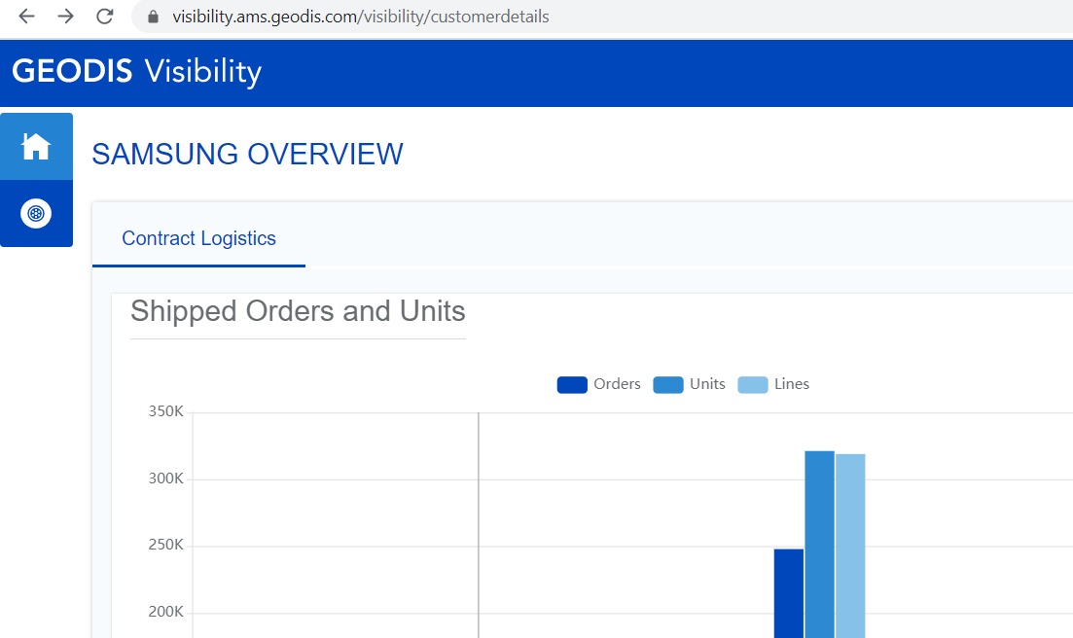
Click this button to go to Control Tower

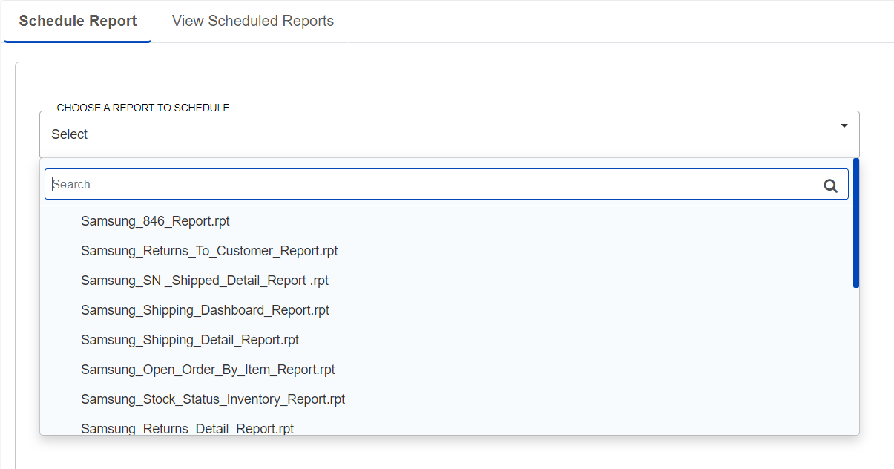
Select the desired report to generate
      - Select Report Type as Excel Spreadsheet > Run Report
    - Go to Reports > Schedule Report > Click on drop down box > Samsung Stock Status Inventory report.
      - Select Report Type as Excel Spreadsheet > Run Report.
    - Both reports should now be available to download
      - Go to Reports > View Scheduled Reports > Click on excel sheet icon next to your name to download.

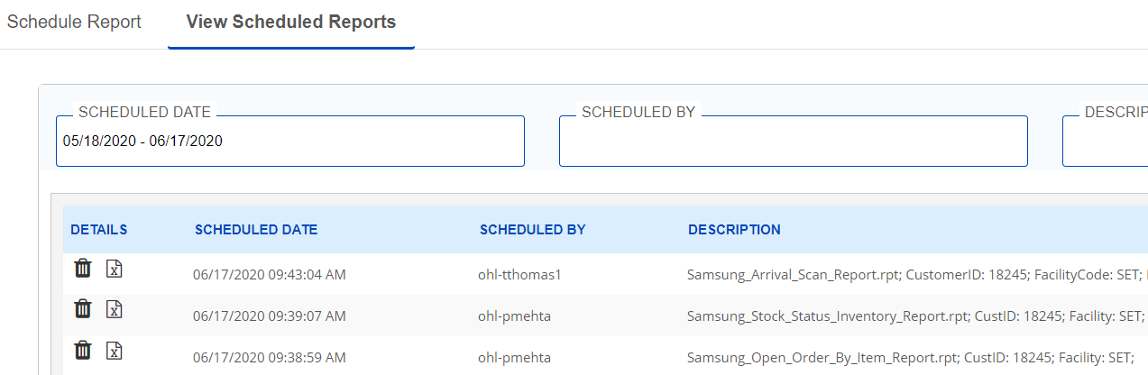
2. Click on the excel icon to download report
1. Click on this Tab

    - Go to Control Tower – drop down>Search – drop down > Advanced Search.
      - Select Order Type drop down box > Uncheck All > only select ‘Outbound Shipment Order’.
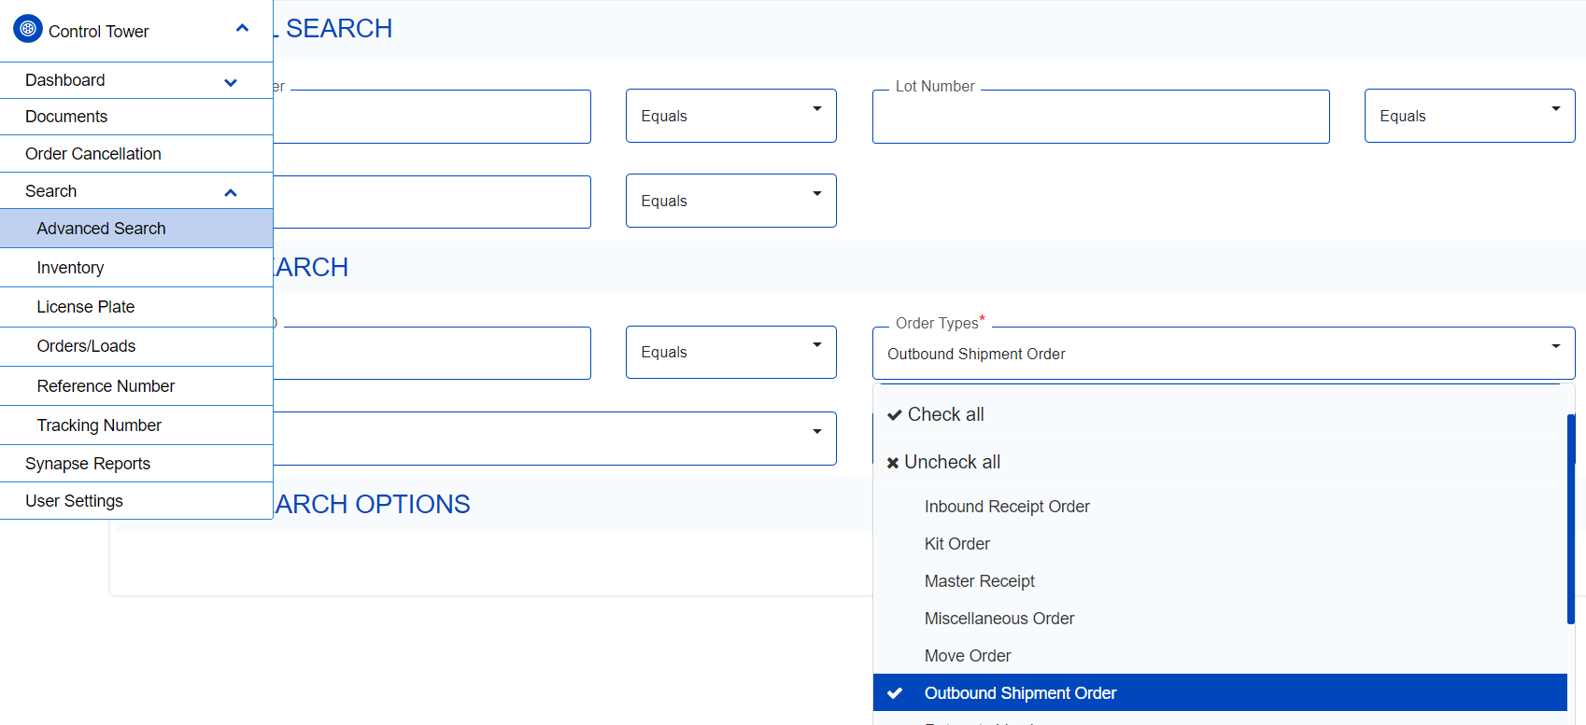
2. Click to open dropdown
4. Only select this option
3. Click here

1. Click on ‘Advanced Search’
    - Select Entry Date box > Last 30 days>Apply.
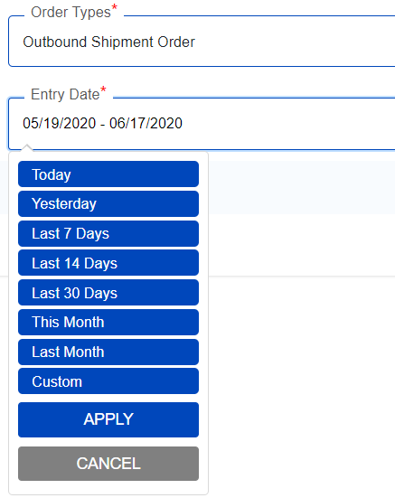
3. Select Apply

2. Select 30 days

1. Click for selecting date

    - Click Search > *on next window* Click on excel sheet icon (3rd from top right) to download.
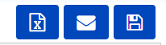
Click on excel icon to download
  - Merge all 3 reports into 1 report: Open a new blank excel file [Main File]
    - Create Column Headers: [Order ID], [Item], [Item Desc], [Entry Date], [Entry Time], [Report Date], [PO ID], [Available Inventory], [Synapse Status], [Delta], [Comments], [Type], [Issue].

    - Open Samsung Open Order by Item report [File (OOR)].
      - Remove first three rows, copy columns [Order ID], [Item], [Item Desc], [Entry Date] to Main File.
      - Using ‘Text to Columns’ feature under Data Tab, separate [Reference] by ‘_’, (note: make sure to insert a couple empty columns next to this column first), copy the column to [PO ID] in Main File.
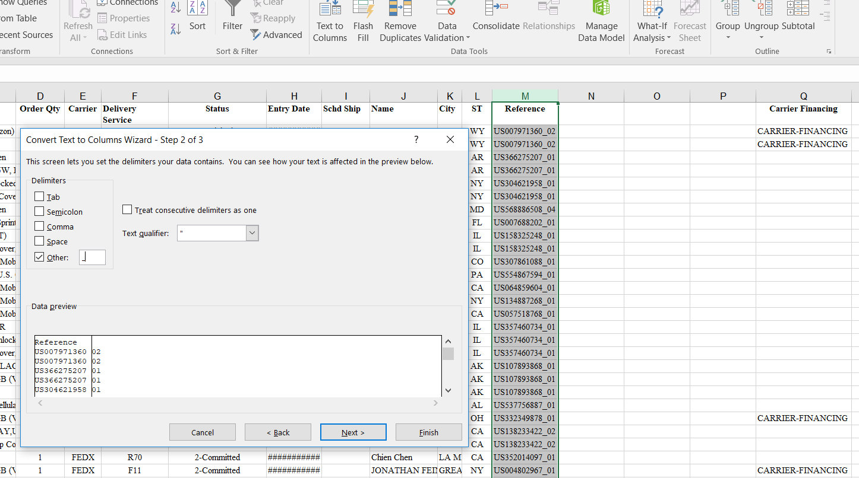
4. Click ‘Finish’
3. Select ‘other’ and insert ‘_’
2. Click to select row
1. Click here to open dialog box
      - Copy [Carrier Financing] column to [Type] column in Main File.
    - In File (x) [Entry Time] – 2nd cell E2 formula bar, type ‘=mod(d2,1)’ and extend to the whole column.
      - In excel file, Goto Home tab > Number Setting.
        - Configure Column D as a Short Date
        - Configure Column E = Time
        - These configurations accounts for Sundays and the time a DO drops
          - IF the file shows 1 day or more then the package is late.
    - In [Delta], copy paste the below formula in cell J2 and extend to the whole column.
      - =MAX(IF(NOW()-TODAY()>TIME(17,0,0),IF(MOD(D2,1)>TIME(17,0,0),IF(NOW()-TODAY()>MOD(D2,1),ROUNDDOWN(NOW()-D2,0),ROUNDUP(NOW()-D2,0)),IF(NOW()-TODAY()>MOD(D2,1),ROUNDUP(NOW()-D2,0),ROUNDDOWN(NOW()-D2,0)))- IF(AND(WEEKDAY(D2,1)=1,MOD(D2,1)>TIME(17,0,0)),INT((WEEKDAY(D2-7,2)+NOW()-D2)/7)-1,(INT((WEEKDAY(D2-7,2)+NOW()-D2)/7))),IF(MOD(D2,1)<TIME(17,0,0),IF(NOW()-TODAY()>MOD(D2,1),ROUNDDOWN(NOW()-D2,0),ROUNDUP(NOW()-D2,0)),IF(NOW()-TODAY()>MOD(D2,1),ROUNDUP(NOW()-D2,0),ROUNDDOWN(NOW()-D2,0)))-IF(AND(WEEKDAY(D2,1)=1,MOD(D2,1)>TIME(17,0,0)),INT((WEEKDAY(D2-7,2)+NOW()-D2)/7)-1,(INT((WEEKDAY(D2-7,2)+NOW()-D2)/7)))))
    - After opening Samsung Stock Status Inventory Report [File (SSIR)], go back to [Main File].
      - Using Vlookup or Index Match, fill in [Available Inventory] by looking up values of [Item] in File (SSIR), and retrieving data from [Available] column.
      - To remove link with other files, copy the column data and paste the values in the same column.
    - After opening “AdvanceSearchResults” file [File (ASR)], go back to the Main File.
      - Using Vlookup or Index Match, fill in [Synapse Status] by looking up values of [Order ID] in File (ASR), and retrieving data from [Status] column.
      - Make sure to copy the column and paste the values in the same column to remove link with other files.
      - Use Conditional Formatting to Highlight [Available Inventory] for <20 and [Delta] for >1.

  - Investigating and reporting process
    - The report shows the orders by date, which gives all the orders not fulfilled on time and ageing for various reasons.
    - Goal is to determine the issues and the document them in the comments. Start with first order in report.
    - Common Scenario 1: Carrier Finance in ‘Picking complete’ status.
      - If the order type is Carrier Finance and Synapse status is ‘Picking complete’, copy the PO ID of the order.
      - Go to v4: https://opstools-us.seasam.org/ops-web/cs/search-order and sign in.
      - In the search bar, paste the PO ID and select Search.
      - In the next page, check status on top right.
Check Status here
      - If status is canceled, go to ‘Cancelled Items’ and note the reason for cancelation.
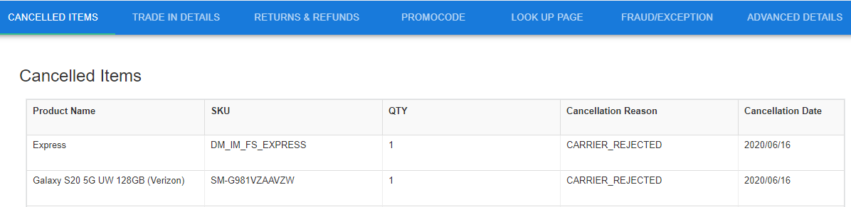
If Status: Cancelled, 1. Click on this Tab
2. Note reason

        - Update Cancellation Reason in the comments column of the report.
        - Email Geodis team to ask if they have received any cancelation signals for that order. If not, instruct to cancel.
      - If status is anything else, go to ‘Order Log’ tab and note the recent log event update (disregard all the ‘order is viewed’ rows, or any Customer Service events that is not related to operations).
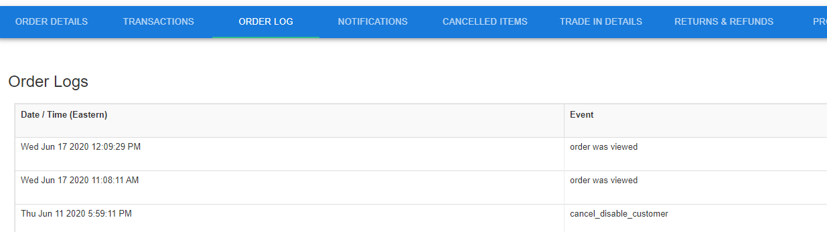
2. Note recent Event, other than ‘orders was viewed’ etc
1. Click on this tab
        - If recent event is ‘cancel_disable_customer’, then SEA did not receive pre-ship signal and IMEI was not shared.
          - Instruct Geodis to de-pick and re-pick the order to get the signal sent.
        - If recent event is ‘IMEI shared with carrier’, then ‘pre_ship_advice_response_sent’ was not triggered, so a system issue is likely in SEA’s system.
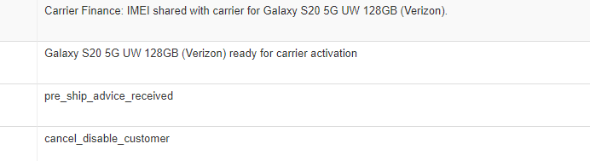
          - Update this code in the comments
          - Email Fulfillment Engineering and Product Support for assistance:-
            - USfulfillmenteng@sea.samsung.com
            - USprodsupport@samsung.com

    - Common Scenario 2: Unavailable inventory.
      - If available inventory for an order shows ‘0’, then copy the SKU from Item column.
      - Go to visibility website https://visibility.ams.geodis.com/visibility/customer and sign in.
        - Go to Control Tower - drop down > Search – drop down > Inventory.
        - Enter SKU in Item ID box and click search button.
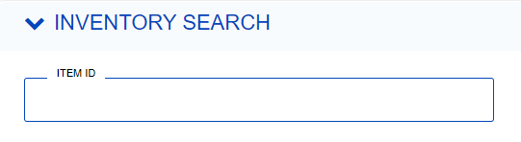
        - Click on the details button (the eye symbol).
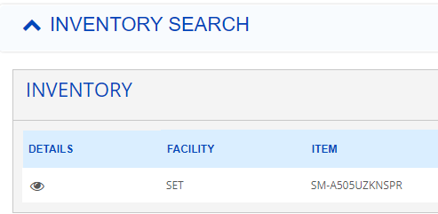
Click on the ‘eye’ icon

        - Click on + sign next to inventory.
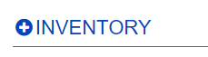
Click on ‘+’ sign to open window
      - If there is ‘on hold’ category, email Geodis to give the status of ‘on hold’ items.
      - If not ‘on hold’, or cannot be released, look up Andrew Ko’s weekly ‘HHP STO’ report in emails.
        - Search the SKU in this report.
          - If item is present, we are receiving STO for that SKU on that week. Update in comments.
          - If item is not present, email SEA eComm teammate in charge of inbound for any upcoming plan on STO for the SKU or anyway to request the SKU. Update in comments
          - If the teammate is not available, ask HQ STO team (Sylvia Chey and Sung Jang) STO plans for the SKU.
      - If no inventory anywhere
        - Since the material is showing on the website, email customer service (Victoria Holter, Saikat Ganguly) and Operations (USprodsupport, Andrew Kim) to inform the customer and cancel in V4, the Samsung customer system.
        - Also, email Michael Schweninger about the inventory issue and mismatch between SAP GMP and Visibility.
        - 24 hours after notifying CS and OPS email Geodis to cancel the order in Synapse
    - Other scenarios are uncommon and usually unique problems. Initial investigation is similar to the scenarios mentioned above.

- Related Documents
  - Example (Double click below image for excel view):

